Assignment -4

Docker and Kubernetes

|  |  |
| --- | --- |
| Assignment Date | 26 October 2022 |
| Student Name | MRIDHUL M |
| Student Roll Number | 713319CS082 |
| Maximum Marks | 2 Marks |

1.Pull an image from docker hub and run it in docker Playground

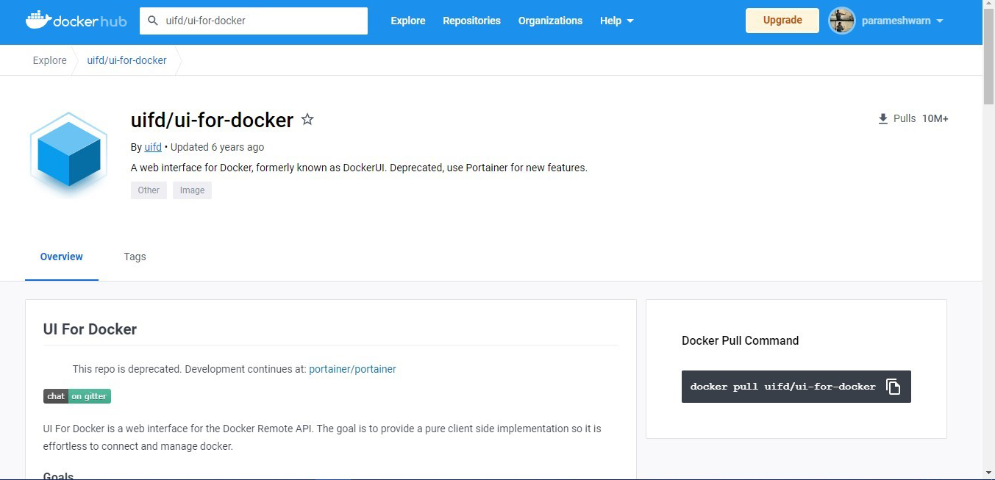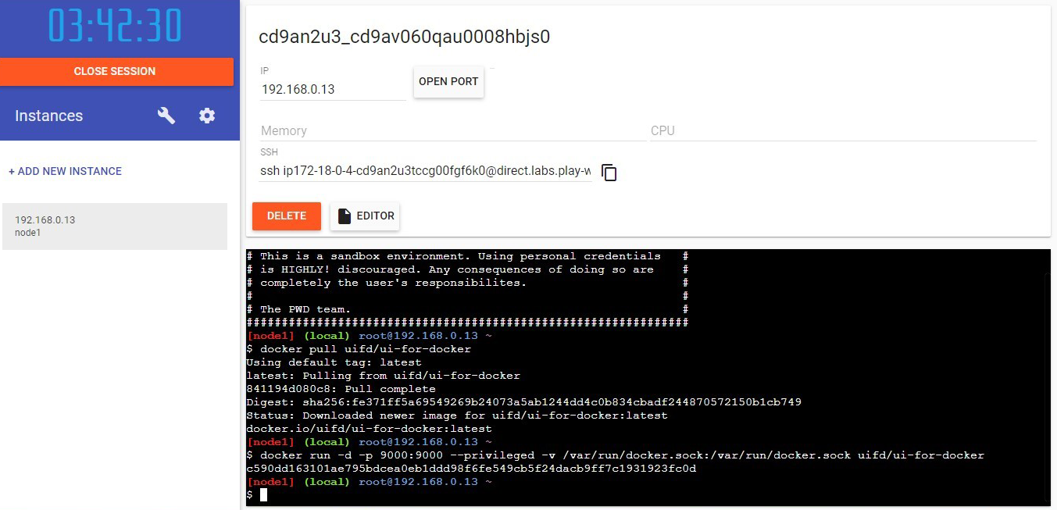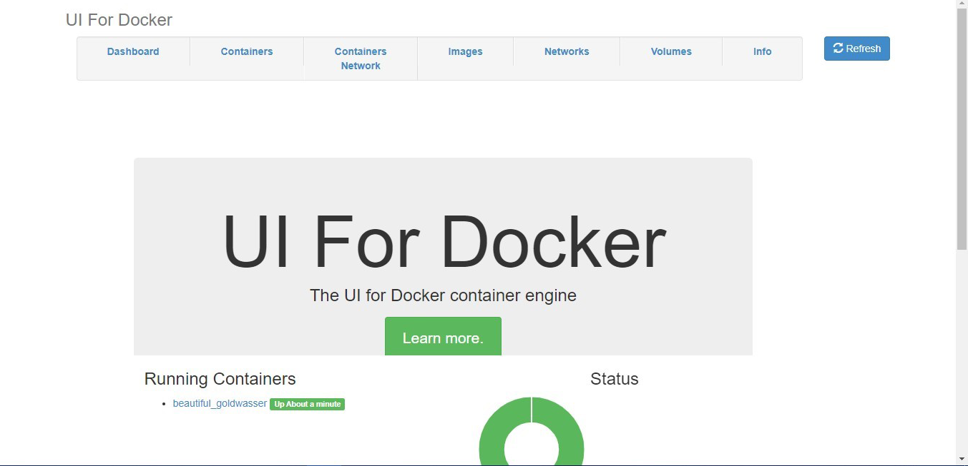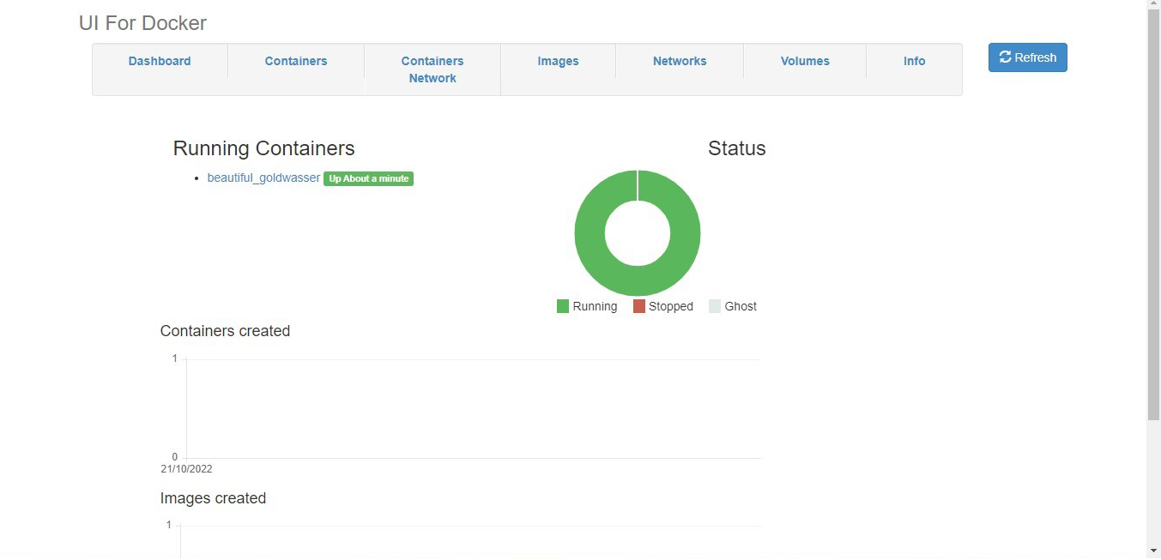

2.Create a docker file for the job portal application and deploy it in Docker desktop application

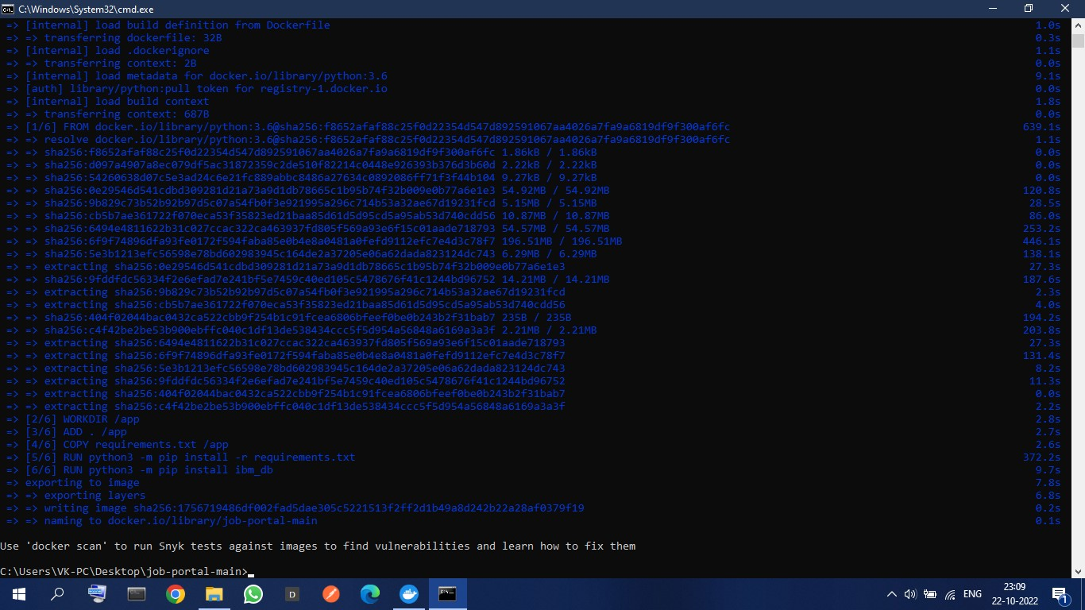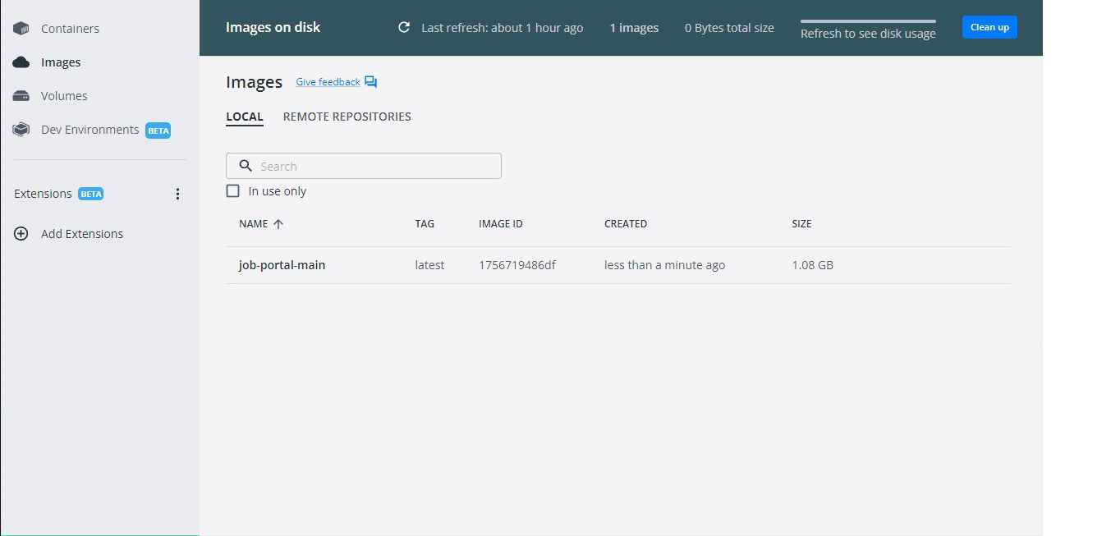

3.Create a IBM container registry and deploy helloword app